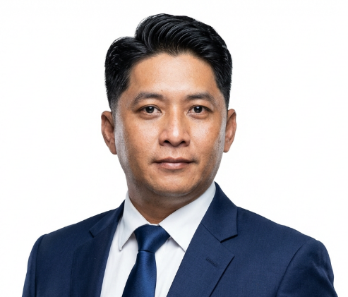
Joseph Rey C. Marilla

Phone: +639175915147 | Email: cxcx25@yahoo.com, cxcx255@gmail.com LinkedIn: linkedin.com/in/josephreymarilla | GitHub: github.com/cxcx25 | Website: https://cxcx25.github.io/MyProfile

Professional Summary

Highly experienced IT and Telecommunications Engineer with a strong foundation in enterprise service desk, identity management, and application development. Currently specializing in Identity and Access Management (IAM), providing Level 2 support for Azure AD (Entra ID), Microsoft 365, SAP systems (via NetIQ Identity Manager), and the NetIQ IAM platform. Passionate about building practical tools and full-stack solutions, including a C# WPF-based Active Directory and Azure AD management application, a complete Barangay Super App MVP (Go + Flutter + React), and Python-based automation tools using PyQt, SQLite, and Selenium.

Experience

Service Desk Analyst L2/IAM | WeSupport Incorporated | Feb 2024 – Feb 2026
- Provided Level 2 IAM support for Azure AD (Entra ID), Microsoft 365, and SAP systems (LUP, DWP, CRM, Fiori, etc.) using NetIQ Identity Manager IAM platform; performed user provisioning, role assignments, access extensions, password resets, and security-related requests in alignment with IAM and compliance standards.
- Actively supported Identity and Access Management (IAM) operations, including account lifecycle management, access reviews, mailbox permissions, and distribution list administration.
- Developed and maintained clear, standardized technical documentation and SOPs, improving consistency, reducing resolution time, and supporting knowledge transfer across service desk teams.
- Managed software deployment and application support through Microsoft Intune and manual installation processes, leveraging RMM tools for remote troubleshooting, monitoring, and device management.
- Administered email and collaboration services, including mailbox access, shared mailboxes, distribution lists, licensing, and PSA system integration.
- Delivered end-to-end IT support covering license assignments, endpoint issues, and network connectivity troubleshooting across diverse enterprise environments.
- Drove automation and tooling improvements by developing PowerShell and Python scripts to streamline repetitive service desk and IAM tasks, including Active Directory automation initiatives.
- Independently designed and developed internal tooling projects, including a C# WPF-based Active Directory and Azure AD management application and a Python desktop notepad, knowledge base, and ticket management application, to improve operational visibility and efficiency.
Personal Projects
Barangay Super App MVP | Full-Stack Community Marketplace January 2026 – Present
- Designed and delivered a complete full-stack Barangay Super App MVP — a production-ready community platform connecting residents for transport services, buy/sell marketplace, messaging, and local services.
- Built high-performance Go backend (modular architecture, JWT authentication, RBAC, repository pattern) integrated with PostgreSQL and Docker orchestration.
- Developed cross-platform Flutter mobile application (MVVM + GetX) and React admin dashboard with secure role-based access control.
- Implemented CI/CD pipelines (GitHub Actions), Verification-Driven Development (VDD), and full security scanning (SAST, SCA, secrets scanning, image scanning) following shift-left principles.
- Deployed via Cloudflare Tunnel for live external access; currently 100% MVP integrated and operational.
At Home Service Desk/TCI | TTEC | Sep 2022 – Feb 2024
- Provided remote Service Desk support via phone, email, and chat, resolving hardware, software, and network incidents.
- Accurately logged and updated tickets in the service management system, ensuring correct categorization and prioritization.
- Followed escalation paths and SLAs for unresolved or critical issues.
- Maintained accurate customer and device records to support reporting and trend analysis.

Service Desk | Concentrix | Sep 2021 – Aug 2022
- Provided technical support to customers across multiple channels (phone, email, chat), diagnosing and resolving hardware, software, and network issues.
- Managed customer issue lifecycle through the ticketing system, escalating unresolved issues efficiently.
At Home Service Desk T1 Voice | TTEC | Oct 2019 – Aug 2021

- Delivered multi-channel technical support for end users.
- Managed incident lifecycle from intake to resolution using ticketing tools.
- Escalated incidents appropriately and documented resolutions for knowledge reuse.
- Contributed to consistent service desk operations and customer satisfaction metrics.
- Demonstrated expertise in technical troubleshooting, data accuracy, and customer service within a regulated industry.
Telecom Engineer | Fahd Abdullah Alireza & Partners Engineering Consultants Co. | Mar 2014 – Mar 2016
- Designed and provided expert consultancy for comprehensive telecommunication systems, including Voice, Data, IPTV, and CCTV, for major projects.
- Prepared detailed Bills of Quantities (BOQ) and Issued for Construction (IFC) drawings.
- Responded to technical queries (TQs) and served as a Revit specialist for architectural, structural, and MEP designs.
Project Engineer and ArcGIS Specialist | SK Engineering & Construction Co. Ltd | Aug 2011 – Aug 2013
- Designed civil, cable, and fiber schematic diagrams for large-scale telecom projects (Mobily and STC).
- Managed GIS data as an ArcGIS Engineer and provided training to personnel on GIS systems.
- Enhanced efficiency by integrating Python scripting into GIS processes.
Telecommunications Engineer | Middle Sea Telecom | May 2009 – May 2011
- Managed and supervised diverse telecom projects, including fiber optic installations and MSAN replacements.
- Conducted thorough field surveys, developed technical solutions, and re-designed as-built plans using AutoCAD.
Telecommunications Engineer | NESCO GROUP S.A | Feb 2006 – Jan 2009
- Oversaw piping projects from survey and strategic planning to installation supervision.
- Redesigned as-built plans using AutoCAD and MicroStation.
- Conducted MSAN commissioning and DSL testing for STC projects.

Education
- B.S. Mechanical Engineer | Mapua Institute of Technology | 1997-2003
- Electronic System Technician | International Elec. & Tech. Ins., Inc. | 1996-1997
- High School | Mapua Institute of Technology High School | 1992-1996
- Elementary | Our Lady of Carmel School | 1985-1992

